Fig.A1: The concentrations of various phytoconstituents of Symplocos racemosa bark (%/g). *The values are expressed as Mean ± SEM for N=3. **Same superscript alphabetic letters within the rows show significant statistical difference (p≤ 0.05) among test organisms as indicated by Post hoc Tukey’s t-test.

Fig.A2: Viable Cell Count studies of the (a) Organic extract (b) Flavonoids (c) Cardiac glycosides of Symplocos racemosa bark and (d) Gentamicin (*Amphotericin B for yeast strains). * SA- Staphylococcus aureus; SE- Staphylococcus epidermidis; EC- Escherichia coli; KP1- Klebsiella pneumoniae 1; KP2- Klebsiella pneumoniae 2; SF- Shigella flexneri; ST1- Salmonella typhimurium 1; ST2- Salmonella typhimurium 2; PA- Pseudomonas aeruginosa; CA- Candida albicans; CT- Candida tropicalis; MRSA- Methicillin- Resistant Staphylococcus aureus.

Fig. A3: Post Antibiotic Effect (PAE) of Symplocos racemosa bark of (1) Ethyl acetate extract (2) Cardiac glycosides (3) Flavonoids against (a) Staphylococcus aureus (b) Salmonella typhimurium 2 (c) Klebsiella pneumoniae 2 (d) Candida albicans.

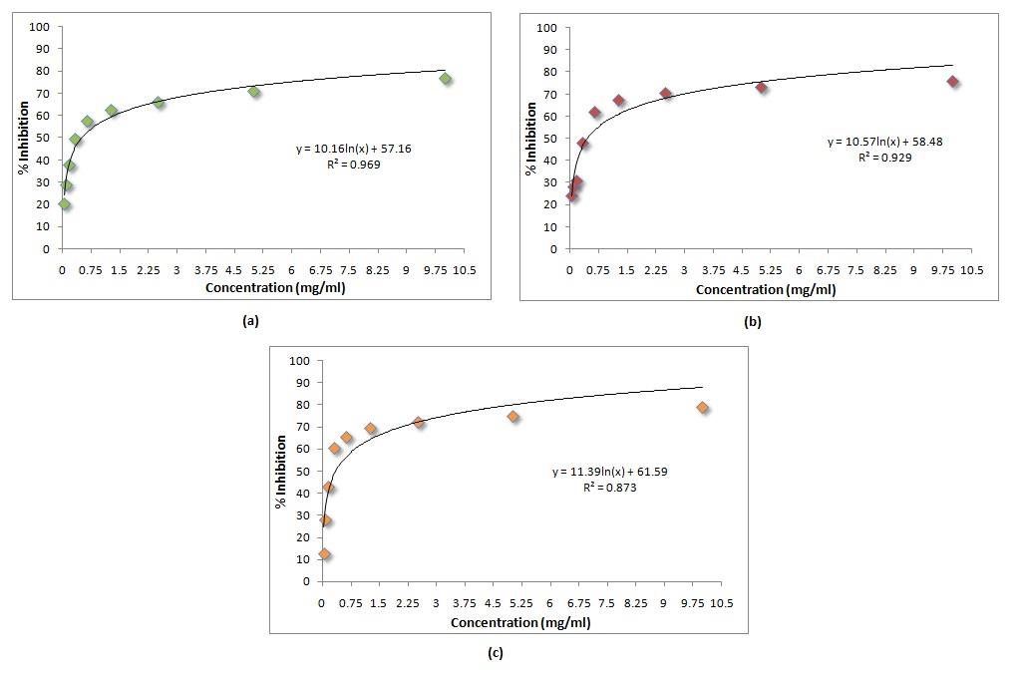

Fig.A4: In vitro cytotoxicity of Symplocos racemosa bark on (a) RD (b) L20B (c) Hep 2 cell line.

Fig.A5: Mean body weight of mice upon dosage of Symplocos racemosa flavonoids. Values are expressed as mean ± SEM (n=6 for each group). Same superscript alphabetic letters above the bars show significant statistical difference. Asterisk denotes (p≤ 0.05) as indicated by Post hoc Tukey’s t-test.

Table TI: MIC and MBC values of the Symplocos racemosa flavonoids against some of the drug resistant strains

Resistant strains | MIC (mg/ml) | MBC (mg/ml)
CRIRS7 | 15 | 20
CRIRS8 | 30 | 35
CRIRS13 | 20 | 25
CRIRS17 | 25 | 30
DSECI03 | 35 | 40
DSECI04 | 35 | 40
DSECI07 | 15 | 20
DSECI09 | 25 | 30
DSECI10 | 15 | 20

